Differential Equations

Some Definitions
- What is differential equation? Give an example.
Ans: A differential equation is an equation that relates one or more functions and their derivatives. It describes how a function changes over time or space.
Here's an example of a simple differential equation:

This equation states that the rate of change of y with respect to x is equal to 2x. To solve this differential equation, you would integrate both sides with respect to x:
= dx
⇒ y = x² + C;
Where C is the constant of integration.

- What is order in differential equations? What is degree?
Order: In the context of differential equations, the order refers to the highest order derivative present in the equation.
For example:
is a first-order differential equation because it involves only the first derivative .
Degree: In the context of differential equations, the degree refers to the highest power of the variable in the equation.
For Example:
+ 3 + 2y = 0 is a second order differential equations.

- What is the general solution of differential equations?
Ans: The general solution of a differential equation is a solution that includes all possible solutions of the equation. It usually contains arbitrary constants that need to be determined using additional conditions, such as initial conditions or boundary conditions, to obtain a unique solution.
For example:
= 2x
The general solution to this differential equation is:
y = x² + C
where C is an arbitrary constant.

- What is the particular solution of differential equation?
Ans: A particular solution of a differential equation is a specific solution that satisfies both the differential equation and any additional conditions that are provided.
Let's illustrate with an example:
Consider the first-order ordinary differential equation:
= 2x
The general solution to this differential equation is:
y = x² + C
To find a particular solution, we need additional information. Let's say we have the initial condition y(0)=1. We can use this condition to determine the value of the constant C.
y(0) = 0² + C = 1
so, C = 1
Therefore, the particular solution to the differential equation with the given initial condition is:
y = x² + 1

Formula:
if , then we can simplify it writing
.
if , then we can simplify it writing
dy = f(x)dx.

Problem 01:
Solve:
Or,
Or, e^{y} + c = e^{x} + c
That’s the answer.

Problem 02:
Solve:
Or,
Or, y =
Or, y = tan⁻¹ +c
That’s the answer.

Problem 03: =
A first order and first-degree differential equation can be written as f (x, y) d x + g (x, y) d y = 0 or d y d x = f (x, y) g (x, y) or d y d x = ϕ (x, y), where f (x, y) and g (x, y) are the functions of x and y.
Given differential equation is =
Or,
on, integrating,
or, +c
or,
or,
or,
∴ = c(constant)
This is the required solution

Problem 04: = (4x+y+1)²
Given equation is, = (4x+y+1)²… … … (1)
Let, 4x+y+1=z then 4+ =
or, =- 4 … … ... (2)
From 1 & 2 equation we get,
- 4 = z²
= 4+z²
= dx
Integrating both sides we get,
½ tan⁻¹ = x+
tan⁻¹= 2x+c
= tan (2x+c)
4x+y+1 = 2 tan(2x+c)
(Answer)

Problem 05: (x - y)² =a²
Put, x-y = v, so
equation is or, =
or, dx = dv =
Integrating, x + C =
or, x+C=(x-y)+a log is the solution.

Problem 06: (x + y)² =a²
(x + y)² =a²
Expand the left Side:
(x² +2xy+y²) =a²
Now, let’s differentiate both sides with respect x:
(x² + 2xy+y²) (x² +2xy+y²) =0
Using the product rule & the chain rule, we get:
2x=0
We have,
This simplifies to:
Integration once:
C₁
Integration again,
Y= C₁x +C₂
Where c₁ and c₂ are constants of integration.

Problem 07:
Given equation is
(x² + y²) dx = 2xy dy
...(1)
Let,
y =vx.
then

From (2) putting the values of dy/dx and y in (1) we get

or,
or,
or,
or,
Integration both sides
+ =0
or, In (v²-1) + lnx = Inc
or, In(v²- 1)x = Inc
or,(v² - 1)x = c
or,
or, y²-x²=cx

Problem 08:

Let , y=vx
= v+ x ……………(2)
From equ (1) and (2) we get ,
V + x
V + x
x =
x =
=

V -
- (Ans)

Homogenous Function:
Homogeneous function is a function with multiplicative scaling behaving. The function f(x, y), if it can be expressed by writing x = kx, and y = ky to form a new function f(kx, ky) = k^{n} f(x, y) such that the constant k can be taken as the nth power of the exponent, is called a homogeneous function.
An equation of the form in which f₁(x, y) and f₂(x, y) are homogenous functions of x and y of the same degree can be reduced to an equation in which variables are separated by putting y= vx ,
Example: Solve: (x²+y²) dx + 2xy dy= 0

We have,
putting y= vx , the equation becomes
= =
or,
=
or, ,
Integrating
or, ln(1+3v²) =ln x
or, ln(1+3)= ln x (Answer)

Equation Reducible to Homogeneous
An equation that is reducible to a homogeneous form is one that, through some transformations, can be converted into a form where the function can be expressed as a ratio of variables, often leading to a separable equation.
Homogeneous Differential Equations
A first-order ordinary differential equation (ODE) of the form:
𝑀(𝑥,𝑦) 𝑑𝑥+𝑁(𝑥,𝑦) 𝑑𝑦= 0
is homogeneous if both 𝑀(𝑥,𝑦)M(x,y) and 𝑁(𝑥,𝑦)N(x,y) are homogeneous functions of the same degree. A function 𝑓(𝑥,𝑦)f(x,y) is homogeneous of degree 𝑛 if:
𝑓(𝑡𝑥,𝑡𝑦)=𝑡^{𝑛}𝑓(𝑥,𝑦)
for any 𝑡∈𝑅.
Transformations to Homogeneous Form
Sometimes, an equation that is not explicitly in homogeneous form can be transformed into one that is. One common transformation is the substitution 𝑦=𝑣𝑥 where 𝑣=y/x ​.
Example: Reduction to Homogeneous Form
Consider the differential equation:
=
This is not homogeneous as is. However, we can make a substitution to reduce it to a homogeneous form.
- Substitution: 𝑦=𝑣𝑥
=v+
- Rewrite the Original Equation: Substitute 𝑦=𝑣𝑥 into the original equation:
𝑣+𝑥=
𝑣+𝑥=
- Simplify:
- 𝑣+𝑥=
𝑣+𝑥=
- Analyze the Terms:
If 𝑐 and 𝑓 are zero, the equation becomes:
𝑣+𝑥
This is a homogeneous differential equation in terms of 𝑣v and 𝑥x.
Solving the Homogeneous Form
- Separate Variables:
𝑥 – v
𝑥
𝑥
- Integrate:
∫ dx
Example-1:Solve the DE dy/dx=(x+2y−1)/(x+2y+1).
Solution:
Note that h, k do not exist in this case which can reduce this DE to homogeneous form. Thus, we use the substitution
x+2y=v
⇒ 1+2 dy/dx
Thus, our DE becomes
1/2(dv/dx−1) = (v−1)/(v+1)
⇒ dv/dx=(2v−2)/(v+1)+1
= (3v−1)/(v+1)
⇒ (v+1)/(3v−1)dv=dx
⇒ 1/3(1+4/(3v−1))dv=dx
Integrating, we have
1/3(v+4/3ln(3v−1))=x+C1
Substituting v=x+2y, we have
x+2y+4/3ln(3x+6y−1)=3x+C2
⇒ y−x+2/3ln(3x+6y−1)=C

Example 2:Reducible to homogeneous differential equation.

Solution: We substitute x→X+h and y→Y+k where h, k need to be determined :

h and k must be chosen so that
2k−h−4=0
k−3h+3=0
This gives h=2 and k=3.𝑘=3. Thus,
x=X+2
y=Y+3
Our DE now reduces to

Using the substitution Y=vX, and simplifying, we have (verify),

We now integrate this DE which is VS; the left-hand side can be integrated by the techniques described in the unit on Indefinite Integration.
Finally, we substitute v = and
X=x−2
Y=y−3
to obtain the general solution.
Suppose our DE is of the form

We try to find h, k so that
ah+bk+c=0
dh+ek+f=0
What if this system does not yield a solution? Recall that this will happen if . How do we reduce the DE to a homogeneous one in such a case ?
= λ (say). Thus,

This suggests the substitution dx+ey=v, which’ll give

Thus, our DE reduces to

⇒
which is in VS form and hence can be solved.

Example 3. Solve (3x-7y-3)
Solution:
Put x= X+h, y=Y+k, where h,k are some constants. Then
And the given eq. becomes,
Choose h,k such that 3h-7k-3=0 and 3k-7h+7=0, which give h=1,k=0.
∴
put Y= , =
∴ =
Or, X= -v =
Or, =
Integrating, 7log X = -2log(v-1)-5log(v+1)+log C
Or, X⁷(v-1)²(v+1)⁵=C
Or, X⁷(=1)²(+1)⁶=C as Y=vX
Or, (Y X)²(Y+X)⁶=C
Or,(y²(y+x-1)⁶=C as x=X+1, y= Y+0

Example 4: Solve the DE =
Solution: Note that h, k do not exist in this case which can reduce this DE to homogeneous form. Thus, we use the substitution
x+2y=v
⇒1+2y =
Thus, our DE becomes

=
⇒
⇒
Integrating, we have

Substituting v= x+2y, we have

⇒y-x+=C

Example 5: Find the solution of the differential equation
Solution: Here, i.e., the coefficients of x and y in the Nr and Dr of the expression for are proportional. Proper substitution in this case, therefore, will be to put v for x + y. Let x + y = v. Then, with these substitutions the given equation reduces to

or
Or
∴ On integrating,
⇒
Or , here v=x + y
Which is the required solution.
Example 6. Solve (2x+y+3)
Solution:
Put x= X+h, y=Y+k, where h,k are some constants. Then
And the given eq. becomes,
Choose h,k such that=0 and=0, which give h=-1,k=-1.
∴
put Y= , =
∴ =
Or, X= -v
Or, =
Integrating, 2log X = -3log(1-v) + log(v+1) + log C
Or, X²(1-v)^{3/}(v+1) = C
Or, X² = C
Or, (X-Y)³ = C(Y+X); where x=X-1, y=Y-1
Or, (X-Y)³ = C(Y+X-2) is the solution.

Example 7: Solve
Solution: The equation is

Put
Or
The equation becomes

=
Or,
∴ Integrating,
; here
,
Which is the required solution.

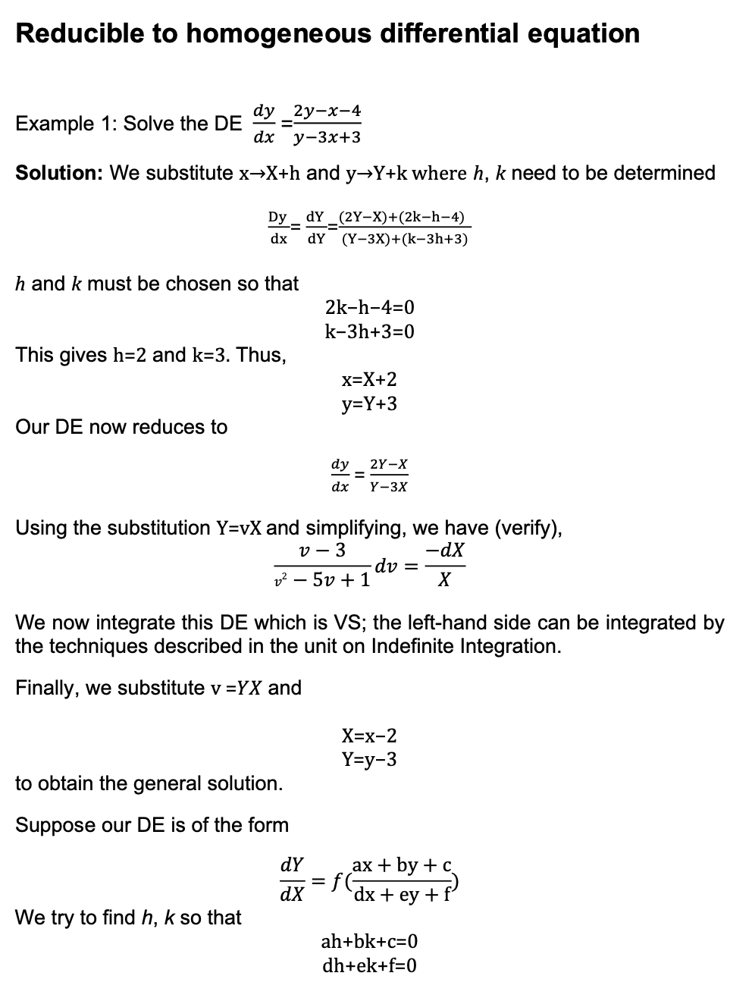
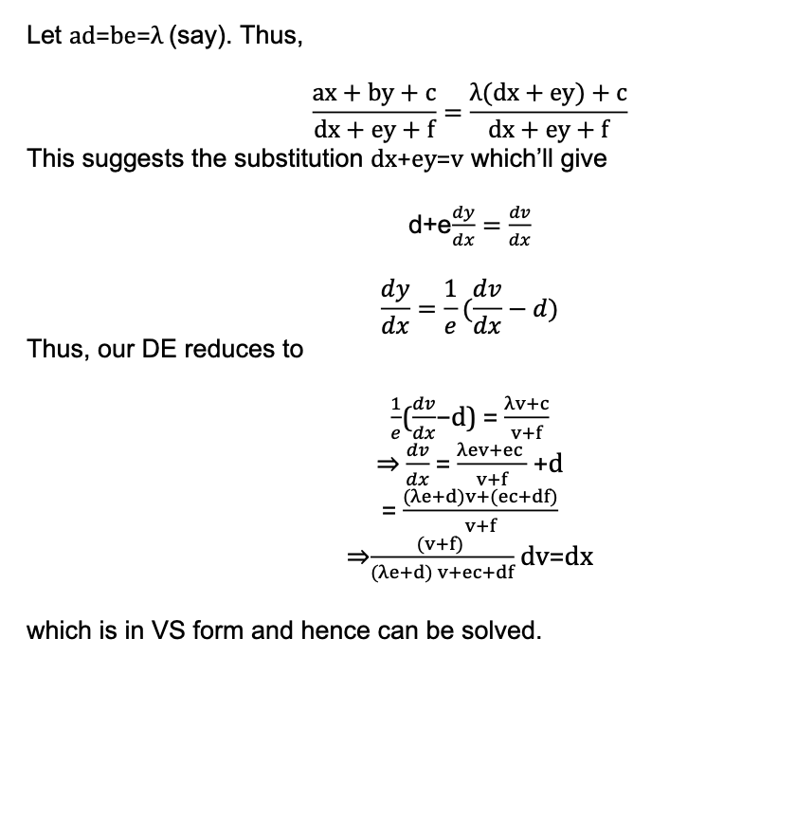

Linear Differential Equation
The linear differential equation is of the form
dy/dx + Py = Q
where P and Q are numeric constants or functions in x. It consists of a y and a derivative of y. The differential is a first-order differentiation and is called the first-order linear differential equation.
To solve this equation, multiply both the sides by the Integrating Factor, I.F = .
So,
dy/dx + Py = Q
^{or,} . dy/dx + P y = Q.
or, d/dx(y. ) = Q
Integrating both sides, with respect to x the following expression is obtained..
or, y. =∫(Q. .dx)
or, y =
The above expression is the general solution of the linear differential equation.

Examples on Linear Differential Equation:
Example 1: Find the general solution of the differential equation
xdy -(y + 2x²).dx = 0

Solution: The give differential equation is
xdy - (y + 2x²).dx = 0.
This can be simplified to represent the following linear differential equation.
dy/dx - y/x = 2x
Comparing this with the differential equation dy/dx + Py = Q we have the values of P = -1/x and the value of Q = 2x. Hence, we have the integration factor as
IF =
or, IF =
or, IF =
Further, the solution of the differential equation is as follows.
=
=
=
2x² + xc
Answer: linear differential equation is 2x² + xc.

Bernoulli Equation:
A equation written in the form
+ P y = Q y^{n}
Is called Bernoulli Equation.

Note: But First notice that if 𝑛=0 or 𝑛=1 then the equation is linear and we already know how to solve it in these cases.
Otherwise,

Working Rule:
- Divide the equation by y^{n}
+ P y = Q y^{n}
y^{-n} + P y^{(1-n)} = Q
- Put y^{1-n} = v then (1-n) y^{-n} =
- Now convert it into + (1-n) Pv = (1-n)Q
- This equation is a Linear Equation.
Now, we have to solve this eq^{n.}
Here, the I.F. =
So, +P (1-n) v = (1-n) Q
Or, ( = (1-n) Q
Or, ( = + C
Which is the required equation.

Example:
Solve this equation-
x + y = y²logx
or, + y = y²logx
or, y⁻² + y⁻¹ = logx
let, y⁻¹ = v
or, -1y⁻¹⁻¹ =
or, -1y⁻² =
Now,
y⁻² + y⁻¹ = logx
or,- += logx
or, - = - logx
here, the I.F = == = = = x⁻¹ =
So, v = +c
Or, = +c
Or, = +c [ v = ]
Thus, The solution is , = +c (answer)

